/\*\*\*\*\*\*\*\*\*\*\*\*\*\*\*\*\*\*\*\*\*\*\*\*\*\*\*\*\*\*\*\*\*\*\*\*\*\*\*\*\*\*\*

\* Programming excercise 73000 \*

\* Maxwell Stephens \*

\* 12:30 TTh \*

\* 73000, 2/17/17 \*

\*\*\*\*\*\*\*\*\*\*\*\*\*\*\*\*\*\*\*\*\*\*\*\*\*\*\*\*\*\*\*\*\*\*\*\*\*\*\*\*\*\*\*/

/\*

This program calculates the inflation for pencils in the future using a for loop to calculate compound inflation.

\*/

#include <iostream>

using namespace std;

int main()

{

//declare vars

double currentPencils, yearsFuture, inflationPercent, inflationDecimal;

//heading

cout << "Pencil Inflation Calculator 2.0 \nBy: Maxwell Stephens" << endl;

//request pencil current price

cout << "Please enter the price of pencils currently" << endl;

//get current price

cin >> currentPencils;

//ask for how many years in the future to calculate for

cout << "Please enter the number of years in the future for\nwhich you would like to know the inflated price" << endl;

//get years

cin >> yearsFuture;

//request inflation rate as a percent

cout << "Please enter the inflation rate as a percent (like 12.5)" << endl;

//get rate as percent

cin >> inflationPercent;

//convert percent to decimal

inflationDecimal = inflationPercent / 100;

//for loop to calculate compound inflation

for (int i = 0; i < yearsFuture; i++) //for loop iteration logic (loops until it is the correct amount of times through)

{

currentPencils += (currentPencils \* inflationDecimal); //adds the inflation to original price, loops again

}

//displays output of what the inflated price will be

cout << "In " << yearsFuture << " years, the price of the pencils will be $" << currentPencils << endl;

system("pause");

return 0;

}

/\*

SAMPLE OUTPUT:

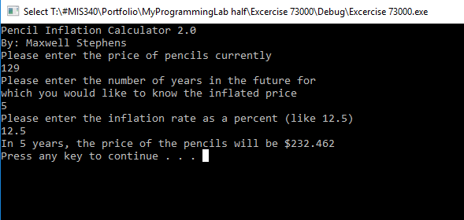

Self-Evaluation:

4: Works perfectly, code properly documented

I believe I earned 4 points.

\*/